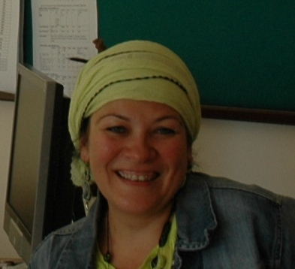
A Visiting Colleague from Poland
This year we have had the pleasure of accommodating a colleague, Brygida Gwiadza-Rzepecka, in our department from Poland. She was here through Erasmus instructor mobility program and worked with us in the department for one week. She visited instructors, some top management people and observed classes. During and after the observations, she shared her ideas with us. She also taught in some classes. We agreed to join in a European Union project if and when a suitable call appears. Below is a short report of her impressions.
We thank Brygida, for coming to Atılım and sharing her experiences with us. We hope to see her again soon. FG &DFL
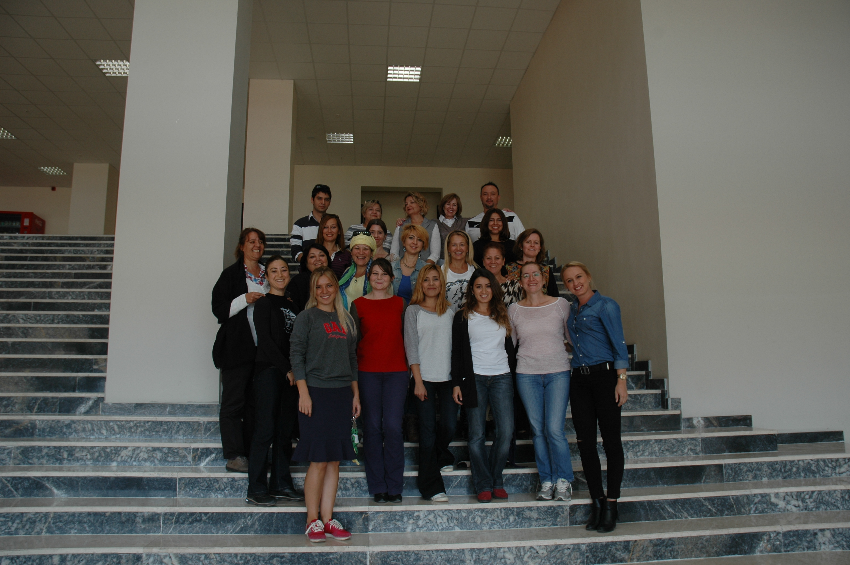
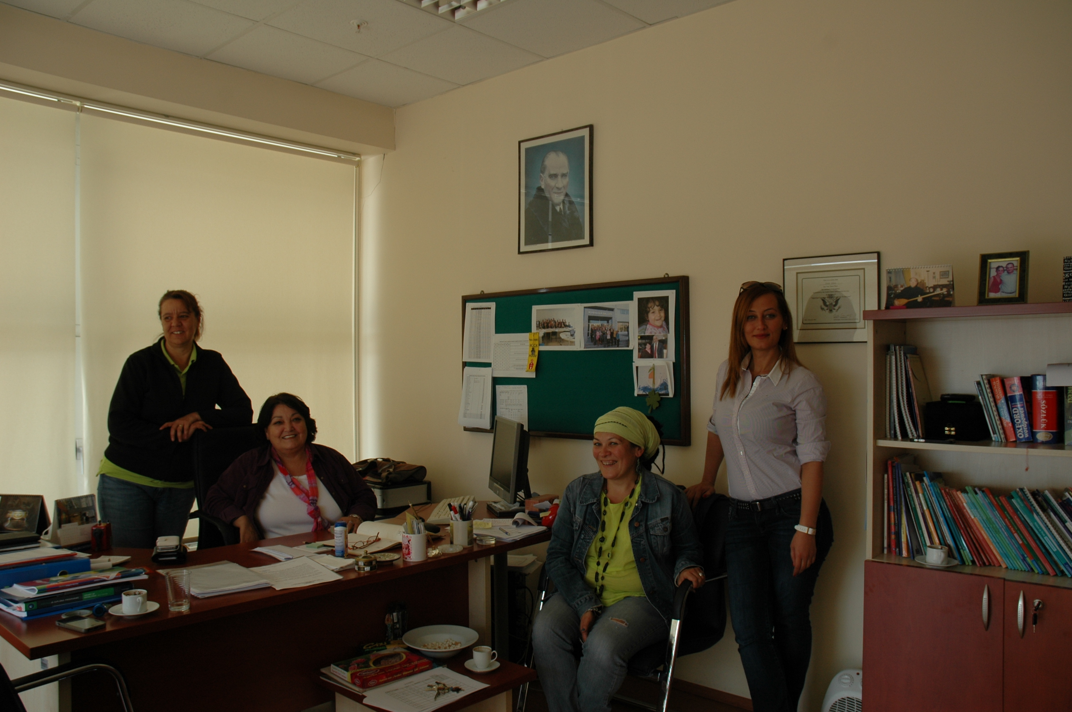
Impressions of Brygida
From 24th to 30th September, I had an unforgettable pleasure to visit Atilim University in Ankara. I will never forget a warm welcome I received and amazing people I met there. Ms Feride Güven, the Chairperson of the Department of Foreign Languages introduced the staff, the university and the campus. I had a unique chance to meet Prof. Dr. Hasan U.AKAY, the Vice Rector of Atilim University, to discuss the future cooperation between our universities. I also had an opportunity not only to teach but also to observe some extraordinary classes taught by really remarkable teachers full of enthusiasm, passion and devotion, the team who help and support each other. I was astonished that some teachers and students knew so much about my country and many of them wanted to know more.
When I came back to Wrocław, Poland, I shared my vivid impressions gained in Turkey with the Rector-Commandant of the General Tadeusz Kościuszko Military Academy of Land Forces, Col. Prof. Mariusz WIATR, PhD who hopes the cooperation between Atilim University and our Academy will enhance.
There is one more person I would like to say special thank you. It is Gulseli Erdem, who made my stay perfect. Thank her for being there, for spending all her free time with me, for showing me how interesting Turkish culture is, how beautiful Ankara is, how delicious Turkish cuisine is and how hospitable and frank Turkish people are.
Brygida

